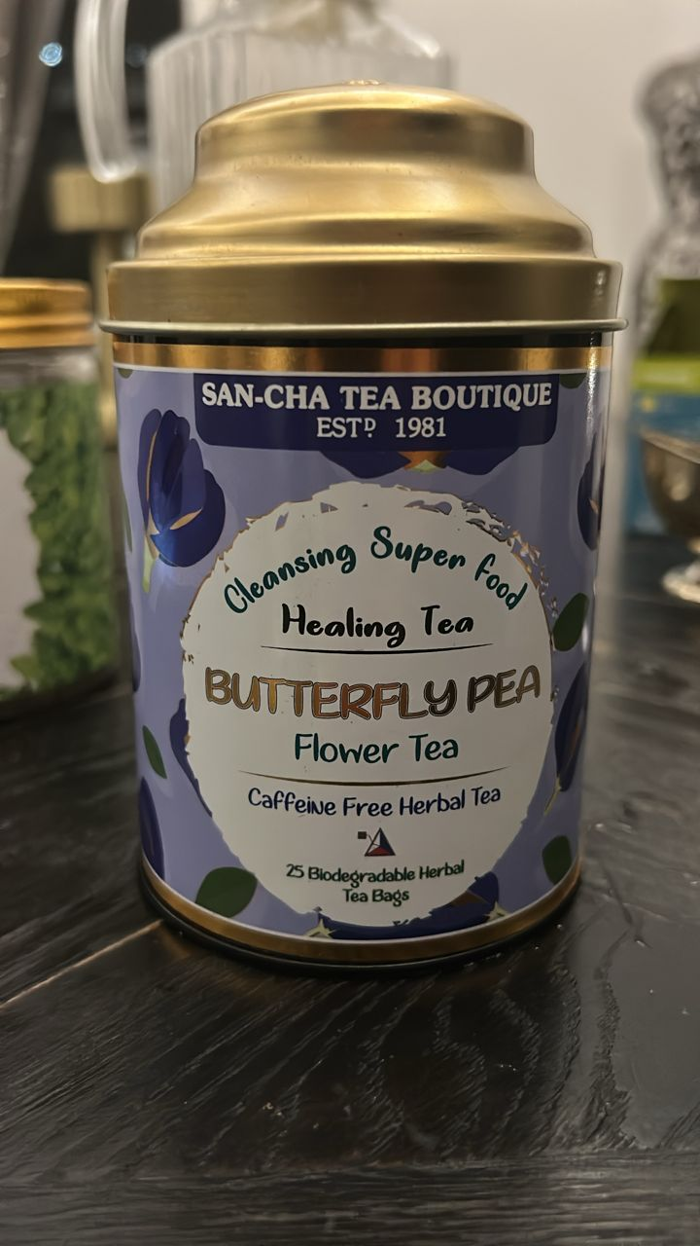
Butterfly Pea Flower Tea
What it is?
- Butterfly pea flower tea (Clitoria ternatea) — a caffeine-free herbal tea made from the blue petals.
- Naturally rich in anthocyanins (ternatins) , which give the deep blue color.
- Add a squeeze of lemon/lime and it changes from blue to purple (pH effect).
Benefits (and the flipside)
Pros
- Caffeine-free hydration; easy evening drink.
- High in antioxidant pigments; works as a natural food/drink color.
- Early research suggests a mild blunting of post-meal blood sugar (don’t treat it as medicine).
- Gentle, earthy taste; great for mocktails and iced teas.
Cons / cautions
- Human evidence is limited overall.
- May lower blood sugar or blood pressure a bit—monitor if you take related meds.
- Pregnancy/breastfeeding: safety unclear; best to skip unless your doctor okays it.
- Use petals/tea bags only (not seeds). Very strong brews can upset the stomach.
How to take it
- Hot brew: 1 tea bag (or ~1–2 g petals) in 250 ml near-boiling water; steep 5–10 min, covered. Optional: lemon/lime (color flip), honey, mint, lemongrass, or ginger.
- Cold brew: 1 tea bag per 250–300 ml cold water; steep 4–8 hours in the fridge; strain. Serve over ice; add citrus to turn purple.
- How much: Start with 1 cup/day, then 1–2 cups if you feel fine. It’s caffeine-free, so night use is okay.
- Storage: Keep the tin sealed, dry, and away from light; best within 6–12 months for peak color and aroma.

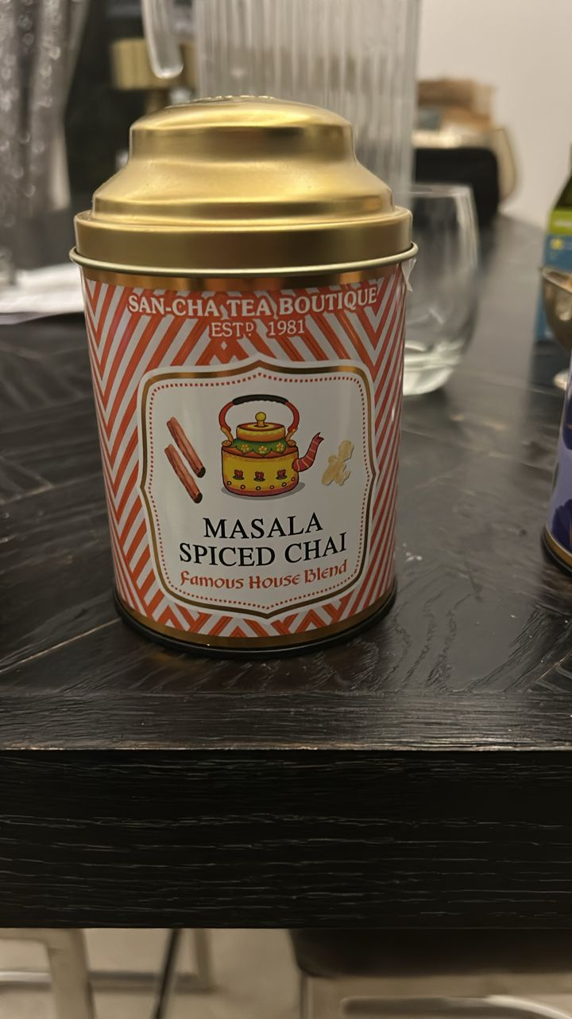
Masala Spiced Chai
What it is
- Masala Spiced Chai — a black tea blended with warming spices (typically cardamom, cinnamon, ginger, clove, black pepper).
- Contains caffeine (rough ballpark: ~30–60 mg per cup depending on brew strength).
- Usually enjoyed with milk and a touch of sugar or honey; rich, sweet-spicy, and energizing.
Benefits Pros
- Alertness + focus from caffeine and L-theanine in black tea.
- Digestive comfort —ginger/cardamom can help nausea/bloating; cinnamon/clove add antimicrobial/antioxidant punch.
- Warming, soothing drink for cold/rainy days; pairs well with milk for a more filling snack.
Cons / cautions
- Caffeine timing: can disturb sleep—avoid late evening. Keep daily caffeine <400 mg (≤200 mg if pregnant).
- Acid reflux/stomach sensitivity: spices + strong tea can aggravate some people.
- Iron absorption: black tea tannins reduce iron uptake—avoid within 1–2 hours of iron-rich meals or supplements.
- Sugar load: café-style chai can be very sweet; control sweetener at home.
- Allergies/intolerances: switch to lactose-free or plant milk if dairy bothers you.
How to take it
- Quick mug (no-fuss):
- 1 tsp loose blend or 1 tea bag in 250 ml freshly boiled water.
- Steep 3–5 min (longer = stronger/more bitter).
- Add 60–120 ml milk (dairy or plant) and sweeten to taste.
- Stovetop “proper” chai (richer):
- Simmer 200 ml water + 150 ml milk with 2 heaped tsp blend for 5–7 min on low.
- Sweeten (1–2 tsp sugar/honey), strain into cup. (For extra kick, add a slice of fresh ginger while simmering.)
- Iced chai / chai latte:
- Brew double-strength (2x tea), chill, pour over ice with cold milk; optional vanilla or a pinch of nutmeg.
- How much: 1–2 cups/day is reasonable. If pregnant or caffeine-sensitive, cap at one small cup and brew lighter.

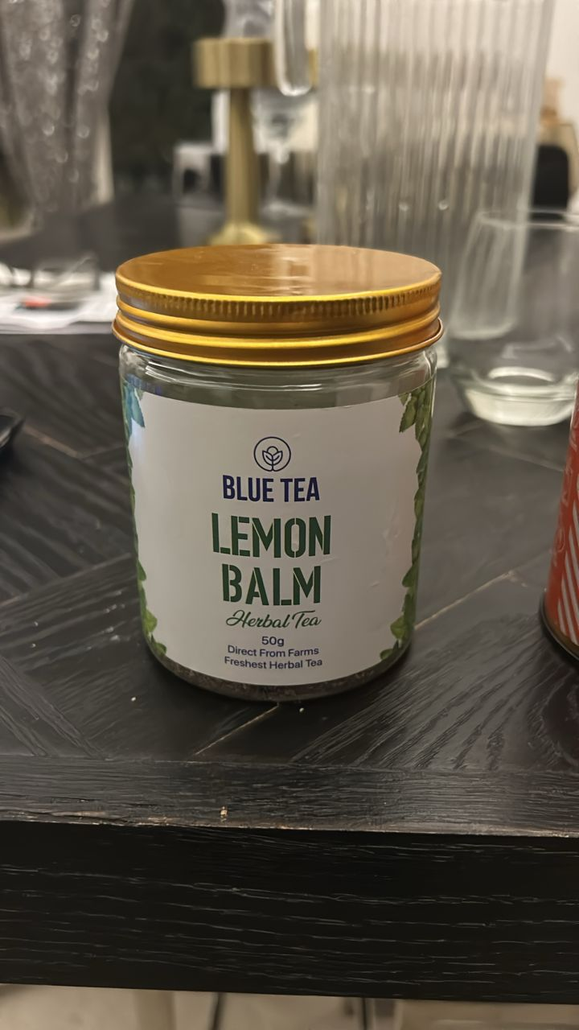
Lemon Balm Tea
WHAT IT IS
  - Lemon Balm (Melissa officinalis) herbal tea — caffeine-free.
  - Light lemony, mint-family leaves; used for calm and digestion.
BENEFITS (and downsides)
  - May help reduce stress/anxiety and improve sleep (mild, natural calm).
  - Gentle digestive relief: bloating, gas, queasy stomach.
  - Can ease tension headaches for some.
  - Antioxidants; nice evening drink.
  - Downsides/cautions: Evidence is mild; not a medicine. May increase drowsiness—go easy if you take sedatives/sleep meds. Use caution with thyroid issues/meds (rare interactions reported). Pregnancy/breastfeeding: not enough safety data—skip unless your doctor says OK.
HOW TO TAKE IT
• Hot brew: 1–2 tsp dried leaves (or 1 tea bag) in 250 ml hot water (90–100°C). Steep 5–10 min, cover, strain.
• For sleep: 1 cup 30–60 min before bed.
• Cold brew: Same amount in cold water; fridge 4–8 hrs, strain.
• Add-ins: honey, lemon, mint, or ginger.
• How much: start with 1 cup/day, then 1–2 cups if you feel good. Avoid right before tasks needing full alertness.
• Storage: airtight jar, cool/dark place; best within 6–12 months.

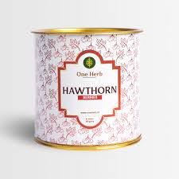
Hawthorn Tea
WHAT IT IS
• Hawthorn (Crataegus) herbal tea/extract—made from the berries, leaves, or flowers.
• Tart–apple, mildly floral taste. Traditionally used for heart and circulation.
• Caffeine-free.
BENEFITS (and downsides)
Pros
• May support heart function and circulation (research uses standardized extracts; tea is gentler).
• Can mildly lower blood pressure and ease “fluttery” palpitations in some people.
• Antioxidant-rich; calming, after-meal friendly.
Cons / cautions
• Not a medicine or a replacement for heart drugs.
• Possible side effects: dizziness, nausea, headache, or palpitations if strong.
• Interactions: can intensify effects of BP/heart meds (beta-blockers, ACE inhibitors, calcium-channel blockers, nitrates, digoxin) and may add to blood thinners (aspirin/warfarin/clopidogrel).
• Pregnancy/breastfeeding: avoid—safety unclear.
• If you have heart disease or take heart/BP/diabetes meds, talk to your doctor first. Stop 1–2 weeks before planned surgery.
HOW TO TAKE IT
• Tea: 1–2 tsp dried berries/leaves/flowers (or 1 tea bag) per 250 ml boiling water. Steep 10–15 min, strain.
• Start with 1 cup/day; if you feel fine, up to 2–3 cups/day. Take with food if your stomach is sensitive.
• Flavor ideas: honey + lemon; or blend with hibiscus/rose/ginger.
• Extract/capsules: only with clinician guidance (research doses often 300–600 mg/day of standardized extract, divided).
• Spacing: keep 2–3 hours away from prescription meds.
• Storage: airtight, cool, and dark; best within 6–12 months.

Mullein Leaves Tea
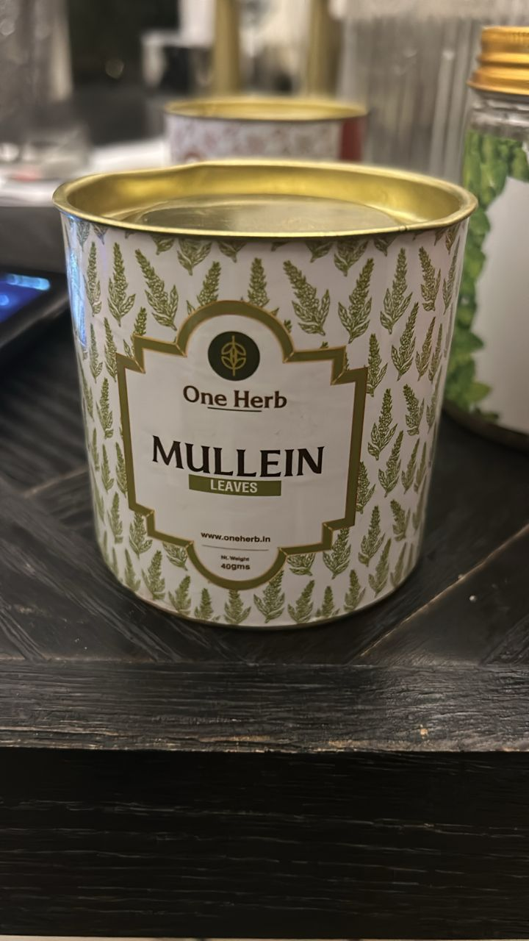
WHAT IT IS
• Mullein leaves (Verbascum thapsus) herbal tea — caffeine-free.
• Traditionally used as a lung/respiratory soother; mild, earthy taste.

BENEFITS (and downsides)
• Pros: May ease dry, irritated cough, help loosen mucus, and calm a scratchy throat (demulcent + gentle expectorant).
• Naturally soothing and hydrating; nice for cold/rainy days.
• Cons/cautions: Evidence is limited—use as a comfort drink, not medicine. The tiny leaf hairs can irritate the throat if not filtered well. Rare skin/plant allergies possible. Pregnancy/breastfeeding: safety unclear—skip unless your doctor says OK. If you have chronic lung disease or severe symptoms, see a clinician.
HOW TO TAKE IT
• Hot tea: 1–2 tsp dried leaves (or 1 bag) per 250 ml near-boiling water. Steep 10–15 min, then strain through a fine mesh/coffee filter to catch the hairs.
• Add-ins: honey, lemon, or ginger.
• How much: start with 1 cup/day; up to 2–3 cups short-term if you feel fine.
• Steam option (for congestion): pour hot water over 1–2 tbsp leaves in a bowl, tent with a towel, breathe gently 5–10 min. Avoid burns; stop if breathing feels worse.
• Storage: airtight, cool, dark; best within 6–12 months.

